**NAME: ABDUL GHANI KHAN**

**ROLL NUMBER: 22P-9037**

**Section: 2A2**

X-OR Gate Using NAND Gate: -

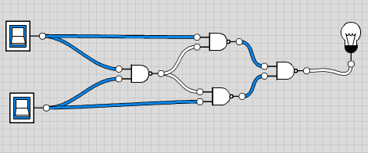

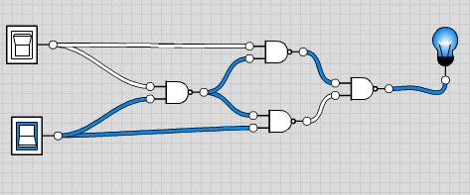

|  |  |  |
| --- | --- | --- |
| Input | | Output |
| 0 | 0 | 0 |
| 0 | 1 | 1 |
| 1 | 0 | 1 |
| 1 | 1 | 0 |

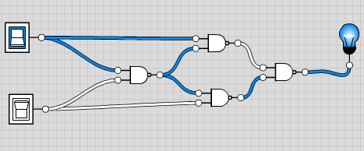

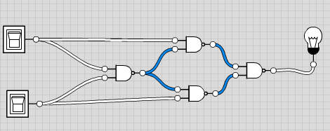

X-NOR Gate Using NAND Gate: -

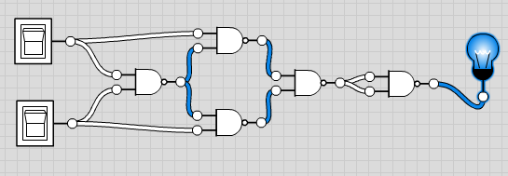

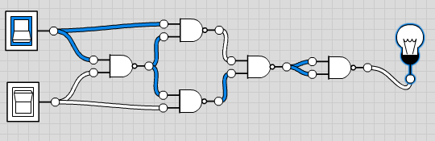

|  |  |  |
| --- | --- | --- |
| Input | | Output |
| 0 | 0 | 1 |
| 1 | 0 | 0 |
| 0 | 1 | 0 |
| 1 | 1 | 1 |

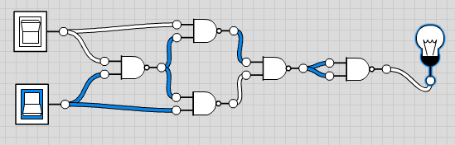

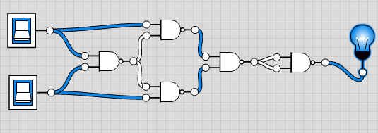

X-OR Gate Using NOR Gate: -

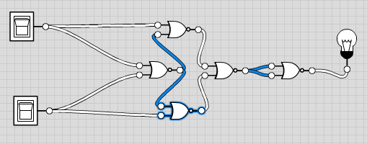

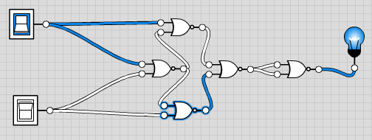

|  |  |  |
| --- | --- | --- |
| Input | | Output |
| 0 | 0 | 0 |
| 0 | 1 | 1 |
| 1 | 0 | 1 |
| 1 | 1 | 0 |

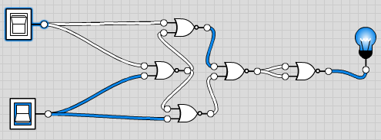

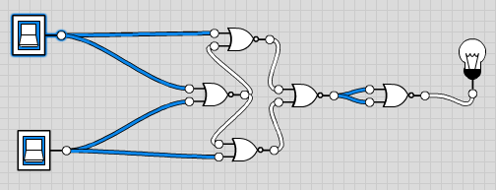

X-NOR Gate Using NOR Gate: -

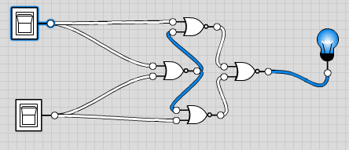

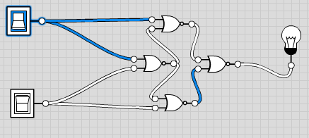

|  |  |  |
| --- | --- | --- |
| Input | | Output |
| 0 | 0 | 1 |
| 1 | 0 | 0 |
| 0 | 1 | 0 |
| 1 | 1 | 1 |

